Football

The playing field is 100 yards long.
• It has stripes running across the field at five-yard intervals.
• There are shorter lines, called hash marks,marking each one-yard interval. (not shown)
• On each end of the playing field is an end zone (red section with diagonal lines) which extends ten yards.
• The total field is 120 yards long and 160 feet wide.
• Located on the very back line of each end zone is a goal post.
• The spot where the end zone meets the playing field is called the goal line.
• The yardage from the goal line is marked at ten-yard intervals, up to the 50-yard line, which is in the center of the field. After reaching the 50-yard line, the yardage markers start to descend (40, 30, 20, 10) every ten yards until they reach the opposite goal line.

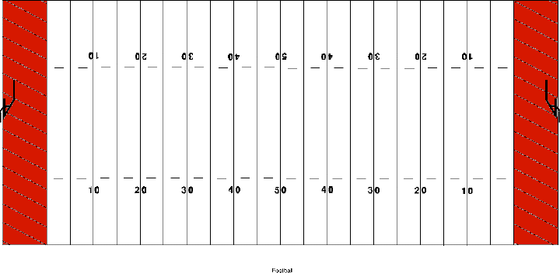
- A kickoff may not score a field goal.
- A kickoff is illegal unless it travels 10 yards OR is touched by the receiving team. Once the ball is touched by the receiving team or has gone 10 yards, it is a free ball. Receivers may recover and advance. Kicking team may recover but NOT advance UNLESS receiver had possession and lost the ball.
- When a kickoff goes out of bounds between the goal lines without being touched by the receiving team, the ball belongs to the receivers 30 yards from the spot of the kick or at the out-of-bounds spot unless the ball went out-of-bounds the first time an onside kick was attempted. In this case, the kicking team is penalized five yards and the ball must be kicked again.
- When a kickoff goes out of bounds between the goal lines and is touched last by receiving team, it is receiver’s ball at out-of-bounds spot.
- If the kicking team either illegally kicks off out of bounds or is guilty of a short free kick on two or more consecutive onside kicks, receivers may take possession of the ball at the dead ball spot, out-of-bounds spot, or spot of illegal touch.

Quarterback (QB)
The player who receives the ball from the center at the start of each play before either handing it to the running back, throwing it to a receiver, or running with it himself. The quarterback is usually the player in charge of running the offense on the field. He is also the guy that usually informs the offense of the play while in the huddle.
Halfback (HB)/Running back
An offensive player who lines up in the backfield and generally is responsible for carrying the ball on run plays.
Fullback (FB)
An offensive player who lines up in the offensive backfield and generally is responsible for run-blocking for the halfback and pass-blocking for the quarterback.
Wide Receiver (WR)
An offensive player who lines up on or near the line of scrimmage, but split to the outside. His primary job is to catch passes from the quarterback.
Tight End (TE)
An offensive player who serves as a receiver and also a blocker. The tight end lines up beside the offensive tackle either to the right or to the left of the quarterback.
Offensive Tackle (OT)
A member of the offensive line. There are two tackles on every play, and they line up on the outside of the offensive guards. Their funciton is to block on both running and passing plays.
Offensive Guard (OG) A member of the offensive line. There are two guards on every play, and they line up on either side of the offensive center. Their function is to block on both running and passing plays.
Center (C) The offensive lineman who hikes (or snaps) the ball to the quarterback at the start of each play. The center lines up in the middle of the offensive line, between the offensive guards. The center also blocks.
Defensive End
A defensive player who lines up at the end of the defensive line. The job of the defensive end is to contain the running back on running plays to the outside, and rush the quarterback on passing plays.
Defensive Tackle
A defensive player who lines up on the interior of the defensive line. The duties of a defensive tackle include stopping the running back on running plays, getting pressure up the middle on passing plays, and occupying blockers so the linebackers can roam free.
Nose Tackle
A defensive tackle who lines up directly across from the center. Also known as:the nose guard, the primary responsibilities of the nose tackle are to stop the run and occupy the offensive lineman to keep them from blocking the linebackers.
Linebacker
A defensive player who lines up behind the defensive linemen and in front of the defensive backfield. The linebackers are a team's second line of defense. Each team has two outside linebackers. In a 4-3 defense, teams have one inside linebacker, usually referred to as a middle linebacker. In a 3-4 defense teams have two inside linebackers.
Cornerback
A defensive back who generally lines up on the outside of the formation and is usually assigned to cover a wide receiver.
Safety
A defensive back who lines up in the secondary between, but generally deeper than the cornerbacks. His primary duties include helping the cornerbacks in pass coverage. There are actually two safety positions; the free safety and strong safety.
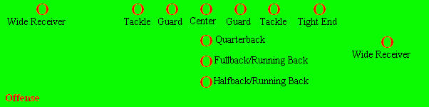
Seven players must line up on the line of scrimmage, and only the two at the end are eligible to catch passes. Teams can vary the number of wide receivers, tight ends and running backs on the field at one time.

Defense
The defensive team or defense is the team that begins a play from scrimmage not in possession of the ball. The object of the defensive team is to prevent the other team from scoring. The sign that the defensive goal has been accomplished is recovering possession of the football before the offensive team scores, which usually involves the offensive team punting the ball on fourth down. Other possibilities include having the ball turned over on downs, getting an interception or recovering a fumble.
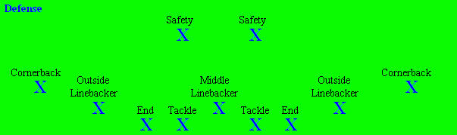
Unlike the offensive team, there are no formally defined defensive positions. A defensive player may line up anywhere on his side of the line of scrimmage and perform any legal action. Most sets used in football, however, include a line composed of defensive ends and defensive tackles and (behind the line) linebackers, cornerbacks, and safeties. Defensive ends and tackles are collectively called the defensive line, while the cornerbacks and safties are collectively called the secondary or defensive backs.

Special Teams
Special teams are units that are on the field during kickoffs, free kicks, punts, field goal and extra point attempts. Most special teams players are second- and third-string players from other positions.
Special teams include a kickoff team, a kick return team, a punting team, a punt blocking/return team, a field goal team and a field goal block team.

There are also specialized players on these teams, including:
- Kicker (K) — Handles kickoffs and field goal attemptsHolder (H) — Usually positioned 7-8 yards from the line of scrimmage, he holds the ball for the placekicker to kick. The holder is often a backup quarterback or a punter.
- Kick returner (KR) — Returns kickoffs, generally is also a wide receiver or cornerback.
- Punter (P) — Kicks punts. In leagues other than the NFL, the kicker often doubles as the punter.
- Punt returner (PR) — Returns punts. Often the same player as the kick returner, although not necessarily so.

